Chinwag session at Swinburne, Tuesday 18 June 2024
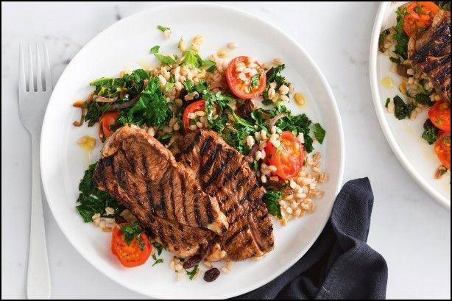
‘Let’s Talk About Food’

Food in your home country
- How different is Australian food compared with the food in your home country?
- What are some of the favourite foods you enjoyed when you lived in your home country? Do you eat the same foods now in Australia?
- Was food in your home country more or less expensive than in Australia?
- Are there any fruit, vegetables or other foods you enjoyed in your home country that are not available here in Australia?

Food culture in Australia
- Describe a normal breakfast you have at home in Australia.
- How often do you get ‘takeaway’ food that you buy that someone else cooks?
- Who normally prepares the meals in your home? And how many people does the person cook for?
- How often do you go to a café or restaurant to eat a meal there?
- Do you look at recipes in books or magazines for ideas on what to cook?
- Talk about what you would eat as a typical evening meal in your home in Australia.
- Where do you shop for your fruit and vegetables?
- Do you watch MasterChef or other cooking programs on television?
- Where do you buy your meat and fish – at a market, supermarket or elsewhere?
- Do you ever visit restaurants serving food from your own country or food from other countries, for example Chinese, Indian, Burmese, Greek and Japanese.

ajeffrey

