Chinwag session at Swinburne, Tuesday 23 July 2024

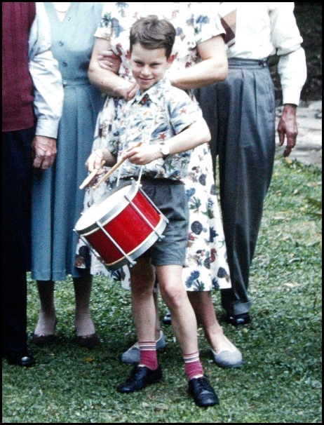
Let’s talk about our childhood!
- What is the earliest memory of when you were a child?
- Have you any brothers or sisters?
- Did you have grandparents when you were a child?
- What can you remember about the home you grew up in?
- Did you have a special toy when you were growing up?
- Can you remember your first day at school?
- Tell the group what sort of indoor and outdoor games you enjoyed as a child.
- When you were a child, can you remember special days each year that your family celebrated, for example Chinese New Year?

ajeffrey

06/240723

