Chinwag session at Swinburne, Tuesday 3 September 2024
Swinburne Library, 2.35pm – 3.35pm

Tuesday’s Terrific and Talented Talkative Team!

> Part 1. Let’s get started

Let’s hear from everyone here today with each of you offering a short chat about any topic you like!

For example, something new or different you did recently, a shopping story, a funny thing that happened to you, perhaps something you have read or a new place you visited. Talking about ANY topic will be good practice for improving your conversational English!
> Part 2. What is an idiom?

An idiom is a phrase (a collection of words) that means something different from its literal (actual or real) meaning.

For example, the phrase ‘it's raining cats and dogs’ is an idiom. It does not mean cats and dogs are falling from the sky. Instead, it means it is raining very hard.

More idioms are explained below:

A piece of cake

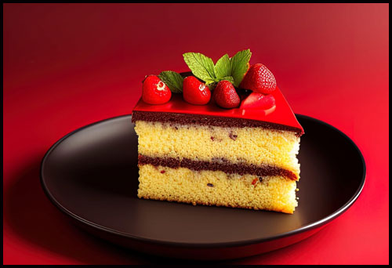

Saying ‘It’s a piece of cake’ about something means that the task is easy.

Question: ‘Do you know how to light the barbecue?’
Answer: ‘I have done it many times before - it’s a piece of cake!’

The tip of the iceberg



If you say that a problem is just the ‘tip of the iceberg’, you are saying that the problem is part of a much bigger problem.

Question: ‘I see your garage got flooded by yesterday’s storm. Is there much damage to the flooring?’

Answer: ‘The soggy carpet on the floor is just the tip of the iceberg.”

Don’t count your chickens before they hatch

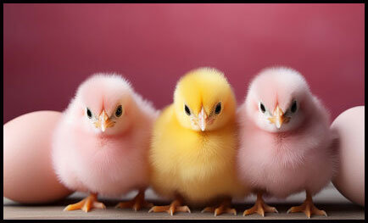

This idiom means don't count on something good happening until it's happened.

Question: ‘I reckon that the Brisbane Lions will win the AFL Grand Final this year!’

Answer: ‘I suggest you don’t count your chickens before they hatch - wait until Grand Final Day!’

It’s water under the bridge



Problems that someone had in the past do not need to be worried about because they happened a long time ago and things cannot be changed.

Question: ‘I am sorry we had that disagreement last month.’

Answer: ‘Don’t be worry, it’s water under the bridge.’

Idioms and sayings from your home country

Do you know of any idioms or sayings that are used in your home country?

Quiz about idioms
What do you think the following idioms mean?
- A bird in the hand is worth two in the bush
- A drop of a hat
- Back to the drawing board
- Cut corners
- Head in the clouds
- You can’t judge a book by its cover
- Make a long story short
- Barking up the wrong tree
- Break the ice
- He’s a chip off the old block

Further information about idioms

Below are three links to websites with more information about idioms, their definitions plus hundreds of examples.

byjus.com

https://byjus.com/english/idioms-in-english/

ef-australia.com.au

https://www.ef-australia.com.au/english-resources/english-idioms/

masterclass.com
https://www.masterclass.com/articles/what-is-an-idiom-learn-how-to-use-idioms-in-writing#3Z0X1g9xbefbxl8JkXpQbG

Shortcut to above masterclass site: idiom-link.ajeffrey.net

> Part 3. Pick-a-Topic-Card!

Topics written on small cards are placed face-down on the table. A student selects one card and speaks about that topic.

If you don’t like the topic on the card you selected, you can put the card back on the table (face-down) and choose another one.

There are lots of different topics to choose from!

Chinwag notes can be downloaded from: https://chinwag.ajeffrey.net

ajeffrey, #11, 3/09/2024

