Chinwag session at Swinburne, Tuesday 17 September 2024
Swinburne Library, 2.35pm – 3.35pm
It’s our Term Break!

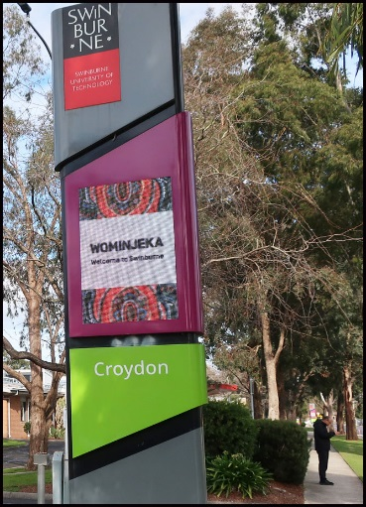

> Part 1. Say goodbye to Term 3!

Term 3 at Swinburne finishes on Friday 20 September. Term 4, the last term for 2024, starts on Monday 7 October.

That gives us all two whole weeks to do lots of things such as relaxing, visiting, walking, talking, playing, planning as well as learning and practising our English!

Let’s talk about what YOU plan to do during this holiday break.

> Part 2. Short chats

Let’s hear from everyone offering a short chat about any topic they like! For example, something new or different you did recently, a funny thing that happened to you, perhaps an upcoming celebration or special occasion.

Talking about ANY topic is good practice for improving your conversational English!

> Part 3. Pick-a-Topic card plus new Roleplay cards!

Conversation topics are written on the small cards which are placed face-down on the table. A student selects one card and speaks about that topic.

If you don’t like the topic on the card you selected, you can put the card back on the table (face-down) and choose another one. There are lots of different topics to choose from!

> Chinwag notes can be downloaded from: https://chinwag.ajeffrey.net

ajeffrey, #13, 17/09/2024

