Chinwag session at Swinburne Library, Tuesday 8 October 2024
2.35pm – 3.35pm



> Part 1. Welcome to Chinwag for Term 4!

To start, let’s hear from everyone with a short talk about any topic they like! Perhaps discuss what you did during the holiday break.

Talking about ANY topic is good practice for improving your conversational English!

> Part 2. What is a Thesaurus?

Agilisaurus, Allosaurus, Brachiosaurus and Brontosaurus are the names of dinosaurs – animals that roamed the Earth many millions of years ago.

But a Thesaurus is not a dinosaur! It is a collection of words that are similar to each other. A Thesaurus is a list (usually in alphabetical order) that shows words that have exactly the same, or nearly the same, meaning.

Words that are related to other words that have similar meanings are called synonyms.

You will increase your English vocabulary, both written and spoken, by using a Thesaurus!

See page 2 to find out where you can locate a copy. Thesauruses are available as books, on the internet and within the Microsoft Word software.

> Part 3. Pick-a-Topic card with the new Roleplay options!

Conversation and roleplay topics are written on the small cards which are placed face-down on the table. A student selects one card and speaks about that topic.

If you don’t like the topic on the card you selected, you can put the card back on the table (face-down) and choose another one.

There are lots of different topics to choose from!

> Where to locate a Thesaurus

From a Library or Bookshop

Thesauruses are published in books. You can find a copy to purchase in many bookshops. You can also read a copy in a public library. Perhaps there is a copy in the Swinburne Library!

Using a Thesaurus on the internet

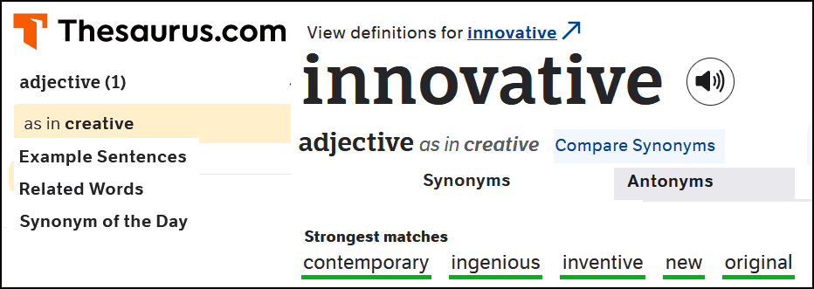

Above: https://www.thesaurus.com is one of many web sites
that cover the topic of synonyms.

Thesaurus feature in Microsoft Word

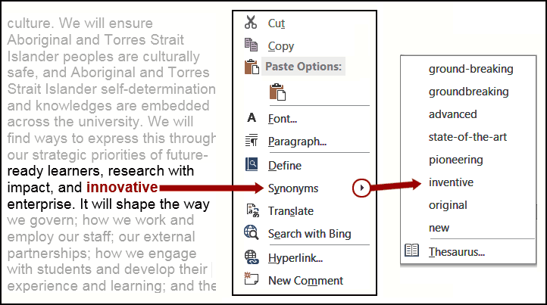

Step 1. Left-click your cursor to place inside the word that you want to search
for its synonym. In the example above (in red) ‘innovative’ has been selected.

Step 2. With the cursor inside the selected word, right-click your mouse to open the
options box shown above.

Step 3. When the options box opens, move your cursor over the word ‘Synonyms’
in the list.

Step 4. A new box will open displaying all the synonyms for the selected word.(Left-click one of the synonyms in the list to replace the original word in your document.)

Note At the bottom of the synonym list there is a further option of clicking the Thesaurus… link or its icon. This will open a new box on the right-side of your computer screen showing additional synonyms.

> Chinwag notes can be downloaded from: https://chinwag.ajeffrey.net

ajeffrey, #14, 8/10/08

