Chinwag session at Swinburne Library, Tuesday 15 October 2024
2.35pm – 3.35pm
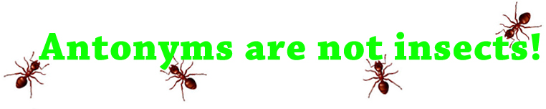

> Part 1. Welcome to the Chinwag conversational English session!

Let’s hear from everyone with a short talk about any topic you like! For example, something you recently did, a new person you’ve met or perhaps details about a recent or upcoming celebration or special occasion.
Talking about any topic is good practice for improving your conversational English!

> Part 2. Welcome to Antonyms!

The Ant, Cockroach, Blowfly, Click Beetle, Earwig and Emperor Moth are all Australian insects – but an antonym is not an insect!

An antonym is a word that means the opposite of another word. For example, hot and cold are antonyms, as are good and bad.

Some more examples are shown on the next page.

(Last week we talked about synonyms, which are words that have exactly the same or nearly the same meaning. A collection of synonyms is called a thesaurus.)

> Part 3. Pick-a-Topic card with Roleplay options!

If we have time, we can play pick-a-topic. Conversation and roleplay topics are written on the cards which are placed face-down on the table.

A student selects one card and talks about that topic.

If you don’t like the topic on the card you selected, you can put the card back on the table (face-down) and choose another one.

There are lots of different topics to choose from!

> All Chinwag notes can be downloaded from:

https://chinwag.ajeffrey.net (Word format)

https://chinwagpdf.ajeffrey.net (PDF format)

AJeffrey #15, 15/10/2024
Some Antonyms
Word | Antonym-1 | Antonym-2 | Antonym-3 | Antonym-4
Absence | Presence | Plenty | Existence | Enough
Accept | Refuse | Fail | Deny | Reject
Accurate | Inaccurate | Indefinite | Unreliable | Faulty
Ancient | Modern | Current | Fresh | New
Answer | Question | Query | Quiet | Trouble
Approval | Disapproval | Denial | Veto | Refusal
Admit | Deny | Repudiate | Expel | Oust
Advance | Retreat | Retire | Behind | Later
Artificial | Natural | Genuine | Real | Unaffected
Ascend | Descend | Drop | Slump | Decline
Attention | Inattention | Disregard | Lethargy | Neglect
Asleep | Awake | Conscious | Attentive | Awake
Ally | Enemy | Antagonist | Detractor | Foe
Agree | Disagree | Reject | Resist | Object

Beginning | Ending | Finish | Epilogue | Finale
Blame | Praise | Approval | Peace | Ratification
Bitter | Sweet | Bland | Pleasant | Mild
Borrow | Lend | Forfeit | Lend | Return
Careful | Rush | Careless | Inexact | Unwise
Calm | Troubled | Harsh | Furious | Worried
Cheap | Dear | Expensive | Expensive | Worthy
Clever | Stupid | Foolish | Ignorant | Naïve
Correct | Incorrect | Improper | Invalid | Biased
Courteous | Discourteous | Rude | Uncivil | Unrefined
Beautiful | Ugly | Drab | Offensive | Repulsive

Gentle | Rough | Surly | Excited | Harsh
Giant | Dwarf | Pygmy | Dwarf | Teeny
Happy | Sad | Miserable | Serious | Morose
Harmful | Harmless | Assisting | Honest | Fortunate
Hate | Love | Liking | Sympathy | Flattery
Healthy | Unhealthy | Ill | Diseased | Infirm
Hinder | Aid | Help | Further | Allow
Honest | Dishonest | Counterfeit | Deceitful | Corrupt
Interior | Exterior | Outside | Revealed | Public
Interesting | Uninteresting | Dull | Repulsive | Homely

For complete list see: https://www.hitbullseye.com/Vocab/List-of-Antonyms.php

