Chinwag session at Swinburne Library, Croydon Campus
Tuesday 22 October 2024, 2.35pm – 3.35pm

The More We Talk, The Better We Get!

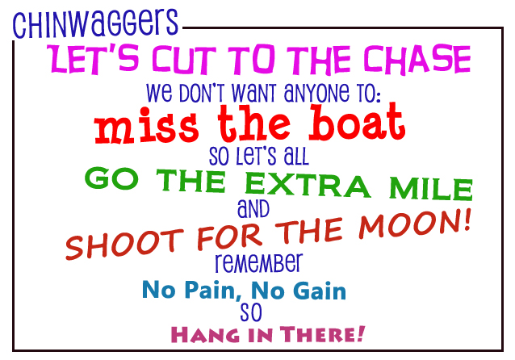

> 1. Idioms!

This topic was first discussed at a Chinwag session on 3 September this year. It’s an interesting subject worth revisiting.

An idiom is a phrase (a collection of words) that means something different from its literal (actual or real) meaning.

For example, the phrase, ‘Let’s cut to the chase’ above, means getting to the point in a conversation. To ‘Miss the boat’ means to miss out on an opportunity. To ‘Shoot for the Moon’ means to aim high in your personal endeavors.

All the words in coloured text in the box above are idioms. Their meanings are explained on the next page along with more examples.

> 2. Let’s hear from You!

Everyone is invited to offer a two-minute talk about any subject they choose! Talking about any topic is always good practice for improving your conversational English!

> 3. Pick a Topic Card Game!

Conversation topics are written on small cards which are placed face-down on the table. A student selects one topic card or roleplay card and speaks on that topic.

If you don’t like the topic on the card you selected, you can put the card back on the table (face-down) and choose another one. There are lots of different topics to choose from!

> Chinwag notes can be downloaded from:

https://chinwag.ajeffrey.net (Word format)

https://chinwagpdf.ajeffrey.net (PDF format)

Some idioms and their meanings

Let’s cut to the chase — Get to the point

Miss the boat — To miss an opportunity

Go the Extra Mile — To put in an extra effort

Shoot for the Moon! — To aim high

No Pain, No Gain — You have to work for what you want

Hang in there — Don’t give up

In hot water — In trouble

Out of the blue — Unexpectedly

Bite the bullet — A difficult situation

Throw in the towel — To give in or quit
On the same page — To be in agreement
All thumbs — Awkward with your hands
Spill the beans — To reveal a secret
See eye to eye — To agree on something
A blessing in disguise — A good thing that seemed bad at first
Better late than never — Better to arrive late than not to come at all
Cut somebody some slack — Not being so critical
Cutting corners — Doing something poorly in order to save time or money
Easy does it – Slow down
Give someone the benefit of the doubt — Trust what someone says
Hit the sack – Go to sleep
It’s not rocket science — It’s not complicated
Let someone off the hook — To not hold someone responsible for something
Pull someone’s leg — To joke with someone
On the ball — Doing a good job
Speak of the devil — The person we were just talking about showed up!
So far so good — Things are going well so far
That’s the last straw — My patience has run out
The best of both worlds — An ideal situation
He’s a chip off the old block — The son is like the father
Time flies when you’re having fun — You don’t notice how long something lasts when it’s fun.

Below are links to websites with additional information, definitions and examples.

byjus.com

https://byjus.com/english/idioms-in-english/

ef-australia.com.au

https://www.ef-australia.com.au/english-resources/english-idioms/

masterclass.com
https://www.masterclass.com/articles/what-is-an-idiom-learn-how-to-use-idioms-in-writing#3Z0X1g9xbefbxl8JkXpQbG

> Shortcut to above masterclass site: idiom-link.ajeffrey.net

andrew jeffrey #16, 22/10/2024

