Chinwag session at Swinburne Library, Croydon Campus
Tuesday 29 October 2024, 2.35pm – 3.35pm

The More We Talk, The Better We Get!

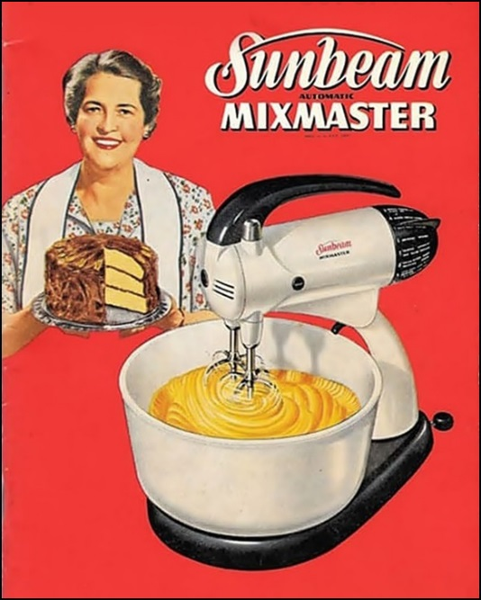



A kitchen is the room in a house, flat or apartment where food is stored, prepared, cooked and, in some cases, where it is consumed.

The kitchen contains many pieces of equipment to preserve and cook the food, utensils to help prepare the food plus crockery (plates, bowls etc.) and cutlery used in the eating of the meal.

But the kitchen is much more than that. In Australian homes, the kitchen has become the heart of a house; a social hub where family members share their thoughts at the end of a day and where friends gather to share a drink or a meal.

The kitchen has not always been the centre of household activity. It used to be a smaller room, away from the living or dining rooms.

These days it has become, for some, part of the dining and living rooms giving additional entertainment space.

Let’s Talk!

> Talk about the kitchens in homes where you have lived – both in Australia
and your home country.

> What are the differences between your kitchen now, and what it was like
in the past?

> Talk about the sorts of equipment you have in your current kitchen
(see list on the next page.)

> How much have you changed your recipes since your moved to Australia?

Kitchen Equipment
Refrigerator (fridge) | Toaster
Freezer (separate to the fridge or  as part of the fridge) | Dishwasher
Stoves and cooktops (gas, electric, induction) | Blender
Ovens (sometimes part of a stove) | Coffee machine
Microwave | Rice cooker
Air fryer | Sunbeam Mixmaster (!)

> What other equipment or utensils have you got in your kitchen?

Some slang (informal) words for Australian foods
Snag – Sausage | Barbie – Barbecue
Bickie – Biscuit | Brekky – Breakfast
Chockies – Chocolate | Cuppa – A cup of tea
Marge – Margarine | Sanger – Sandwich
Mushie – Mushroom | Spag bol – Spaghetti Bolognese
Tucker – Bush tucker is outback food | Pav (Pavlova) – A meringue filled with whipped cream and fruit.
Bangers and mash – Sausages and mashed potatoes. | Bubble and squeak – A dish made by frying leftover meat and vegetables (typically mashed potatoes) together.
Cut lunch – Sandwich | Coldie – A cold bottle of beer.
> Have you heard of any other slang words for food or drinks?

Links

Kitchen Guide

https://www.englishforladies.com/blog/ultimate-kitchen-guide

The life and times of my faithful Sunbeam Mixmaster

A blog by Judith Salecich

https://judithsalecich.com/my-faithful-sunbeam-mixmaster/

The first Australian-made Sunbeam Mixmaster was released in Australian in 1948. It was unique in having two interlocking, detachable beaters and a revolving bowl. It became a much loved kitchen appliance in many thousands of Australian homes. Various versions of the product are still sold today by Sunbeam.

These Chinwag notes can be downloaded from:

https://chinwag.ajeffrey.net (Word format)

https://chinwagpdf.ajeffrey.net (PDF format)

andrew jeffrey, #17 29/10/2024

