Chinwag session at Swinburne Library, Croydon Campus
Tuesday 12 November 2024, 2.35pm – 3.35pm

The More We Talk, The Better We Get!

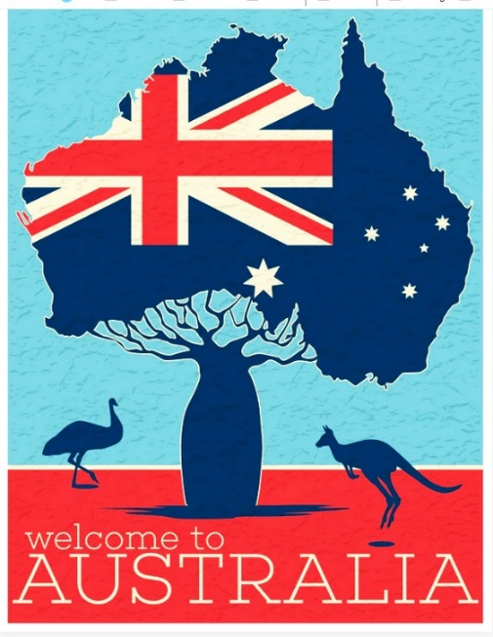

> Part 1. Students Decide!

This afternoon, let’s talk about things that students around the table would like to discuss in relation to life in Australia.

This can be about anything, for example learning English, your home and family life, the challenges of living in Australia, the customs and traditions here that are different from your home country.

These are just some suggestions. You can talk about any subject you like.

> Part 2. Pick a Card and a Topic to Talk about!

Conversation topics are written on small cards which are placed face-down on the table. A student selects one card and speaks about that topic.

If you don’t like the topic on the card you selected, you can put the card back on the table (face-down) and choose another one.

There are lots of different topics to choose from!

These Chinwag notes can be downloaded from:

https://chinwag.ajeffrey.net (Word format)

https://chinwagpdf.ajeffrey.net (PDF format)

andrew jeffrey, #18 12/11/2024

