Chinwag Conversation Get-Together
Swinburne, Croydon campus, Tuesday 11 February 2025

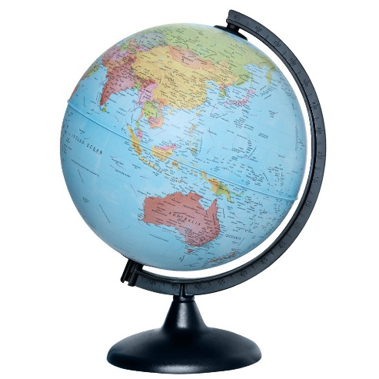

Making a New Life
Let’s talk about how life in your home country was the same as, or different
from, living in Australia.

Arrival and Getting Settled
- How much did you know about Australia before you arrived here?
- Talk about the first week after you arrived in Australia. How did you feel? Did you feel happy and excited, or nervous and a bit confused at how different Australia was?
- Did your experiences in the early years of living in Australia match what you thought it was going to be like?
- Of all the things here in Melbourne that are different to that in your home country, what is one of the biggest differences you have found since you moved to Australia?
Housing
- Can we discuss whether you had any difficulties finding a place to live?
- In what ways is your home here in Australia different to the one in your home country?
Food and Shopping
- Have you changed the types of food you eat at home after your move to Australia?
- How different is the way you shop now?
- How do the prices compare between here and your home country?
Travel and Transport
- Have you ridden on a Melbourne tram?
- Do you regularly use trains to get around Melbourne?
- Have you had the opportunity to travel to other parts of Australia?
Sport & Leisure
- Have you been to the Melbourne City to visit a gallery, museum or other venue?
- Do you follow any Australian sports?
- Do you watch much television? What shows do you enjoy?
- Do you have any hobbies or pastimes?
- Have you joined any local sports or social clubs in Australia?

ajeffrey

# 2, 11/02/2025

