Chinwag Conversation Get-Together
Swinburne campus, Tuesday 18 February 2025

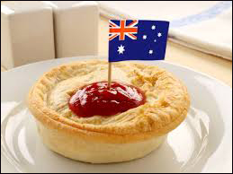
Let’s Talk About Food!

Food in your home country
- How different is Australian food compared with food in your home country?
- What are some of the favourite foods you enjoyed when you lived in your home country? Do you eat the same foods now in Australia?
- Was food in your home country more or less expensive than in Australia?
- Did you buy your food from shops or markets?
- Are there any fruit, vegetables or other foods you enjoyed in your home country
that are not available in Australia?

Your eating habits in Australia
- Do you buy the same sort of food every week?
- Do you buy your groceries from supermarkets such as Coles and Woolworths, or
do you buy from smaller shops and markets?
- Where do you shop for fruit and vegetables?
- Where do you buy your meat and fish – at a market, supermarket or elsewhere?
- Describe a normal breakfast you have at home.
- Who normally makes the meals in your home? How many people does the person
cook for?
- Talk about what you would eat as a typical evening meal at home.
- How often do you get ‘takeaway’ food to eat at home?
- Do you ever go to a café or restaurant to enjoy a meal there?
- Do you look at recipes in books or magazines for ideas on what to cook?
- Do you watch cooking programs on television?
- Do you visit venues that serve food from your own country or food from other countries, for example Chinese, Indian, Burmese, Greek and Japanese?

ajeffrey
#03, 18/02/2025

