Chinwag conversation session
Swinburne campus Library
Tuesday 25 February 2025
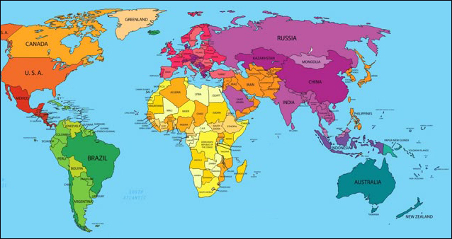
This week’s topic: your home-town
Let’s hear about your home-town - the place where you were born, or grew up in. Here are some ideas for talking about your home-town. Choose some of the questions below.
- What country is your home-town located in?
- Describe your home-town. Is it small or large? Is it a village or a small or large town? Is it inland or near the coast?
- How far is your home-town from the country’s capital?
- What can you remember about growing up in your home-town?
- Did you live in more than one home in your own country?
- Who did you live with?
- How did you get to school?
- Does your home-town have a railway station or port?
- Does a river pass-through your home-town?
- Does your home-town have famous landmarks?
- Do tourists visit your home-town?
- Where did you or your family obtain your food? (market, supermarket or home grown?)
- What did you like most about your home-town?
- How is your house/unit in Australia different from your home in your own country?

> Chinwag notes for 2024 and 2025 can be downloaded from:

https://chinwag.ajeffrey.net (Word format)

https://chinwagpdf.ajeffrey.net (PDF format)

ajeffrey, #4, 25/02/2025

