Chinwag conversation workshop
Swinburne Library, Croydon campus
Tuesday 29 April 2025

Let’s Get Talking!

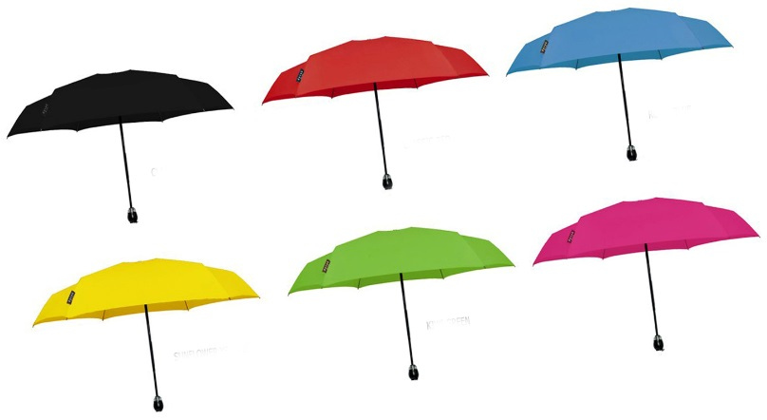

> Australian customs and culture
- What are the things that you have found difficult to take on or get used to about living in Australia?
- What have been the things that have made your adjustment to a new life in Australia easier?
- What are the things you like best like about your new life in Australia?

> Talking about the Australian Federal election
- Who here today is registered to vote in the election to be held on Saturday 3 May?
- Have you received election material in your letterbox?
- How do elections differ in other countries?
- Further information from the Australian Electoral Commission
website: https://www.aec.gov.au/
> Pick a topic card!

A student selects one card on the table and talks about that topic.

If you don’t like the topic you select, put the card back on the table (face-down) and choose another one. There are lots of different topics to choose from!

> Chinwag notes for 2024 and 2025 can be downloaded from:

https://chinwag.ajeffrey.net (Word format)

https://chinwagpdf.ajeffrey.net (PDF format)

ajeffrey, number 10, 29/04/2025

